Linux Systems Administration

### Step 1: Ensure/Double Check Permissions on Sensitive Files

1. Permissions on `/etc/shadow` should allow only `root` read and write access.

- Command to inspect permissions: ls -lt shadow

- Command to set permissions (if needed):sudo chmod 600 /etc/shadow

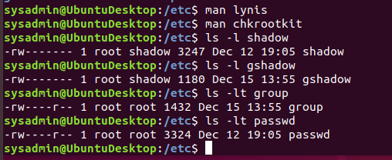

2. Permissions on `/etc/gshadow` should allow only `root` read and write access.

- Command to inspect permissions: ls -lt gshadow

- Command to set permissions (if needed): sudo chmod 600 /etc/gshadow



3. Permissions on `/etc/group` should allow `root` read and write access, and allow everyone else read access only.

- Command to inspect permissions: ls -lt group

- Command to set permissions (if needed):sudo chmod 644 /etc/group



4. Permissions on `/etc/passwd` should allow `root` read and write access, and allow everyone else read access only.

- Command to inspect permissions: ls -lt passwd ls -lt passwd

- Command to set permissions (if needed): sudo chmod 644 /etc/passwd



### Step 2: Create User Accounts

1. Add user accounts for `sam`, `joe`, `amy`, `sara`, and `admin`.

- Command to add each user account (include all five users):

sudo adduser sam

sudo adduser joe

sudo adduser amy

sudo adduser sara

sudo adduser admin

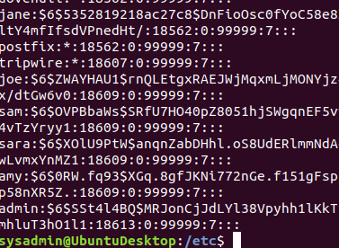

2. Ensure that only the `admin` has general sudo access.

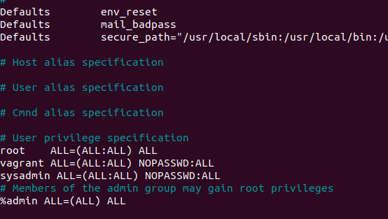

- Command to add `admin` to the `sudo` group: sudo useradd -aG sudo admin

### Step 3: Create User Group and Collaborative Folder

1. Add an `engineers` group to the system.

- Command to add group: sudo addgroup engineers

2. Add users `sam`, `joe`, `amy`, and `sara` to the managed group.

- Command to add users to `engineers` group (include all four users):

sudo usermod -aG engineers sam

sudo usermod -aG engineers joe

sudo usermod -aG engineers amy

sudo usermod -aG engineers sara



3. Create a shared folder for this group at `/home/engineers`.

- Command to create the shared folder:

sudo mkdir -p engineers

4. Change ownership on the new engineers' shared folder to the `engineers` group.

- Command to change ownership of engineer's shared folder to engineer group:

sudo chown :engineers /home/engineers/

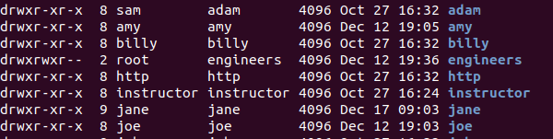

### Step 4: Lynis Auditing

1. Command to install Lynis:

sudo apt install lynis

2. Command to see documentation and instructions:

man lynis or lynis --help

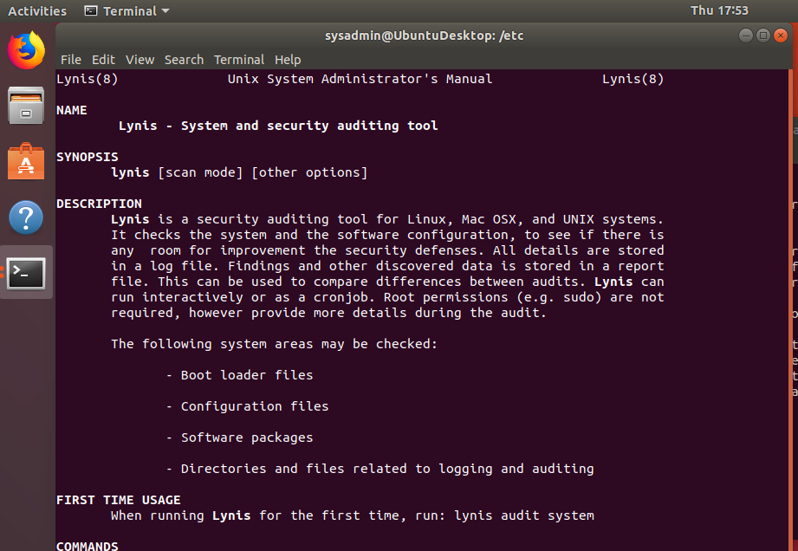

3. Command to run an audit:

sudo lynis audit system

4. Provide a report from the Lynis output on what can be done to harden the system.

- Screenshot of report output:

sudo cat lynis-report.dat | grep suggestion

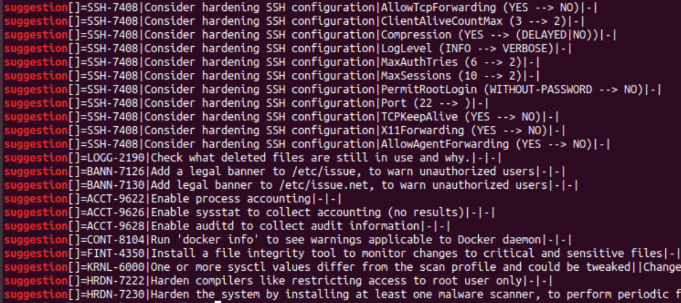

### Bonus

1. Command to install chkrootkit:

sudo apt install chkrootkit

2. Command to see documentation and instructions:

man chkrootkit or chkrootkit --help

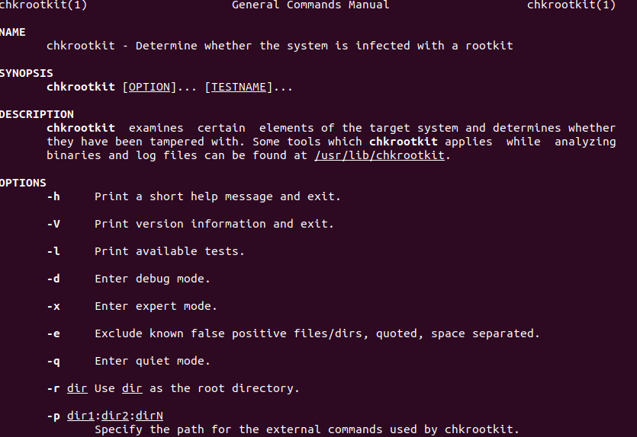

3. Command to run expert mode:

sudo apt install chkrootkit -x

In this mode the user can examine suspicious strings in the binary programs that may indicate a trojan.

4. Provide a report from the chrootkit output on what can be done to harden the system.

- Screenshot of end of sample output:

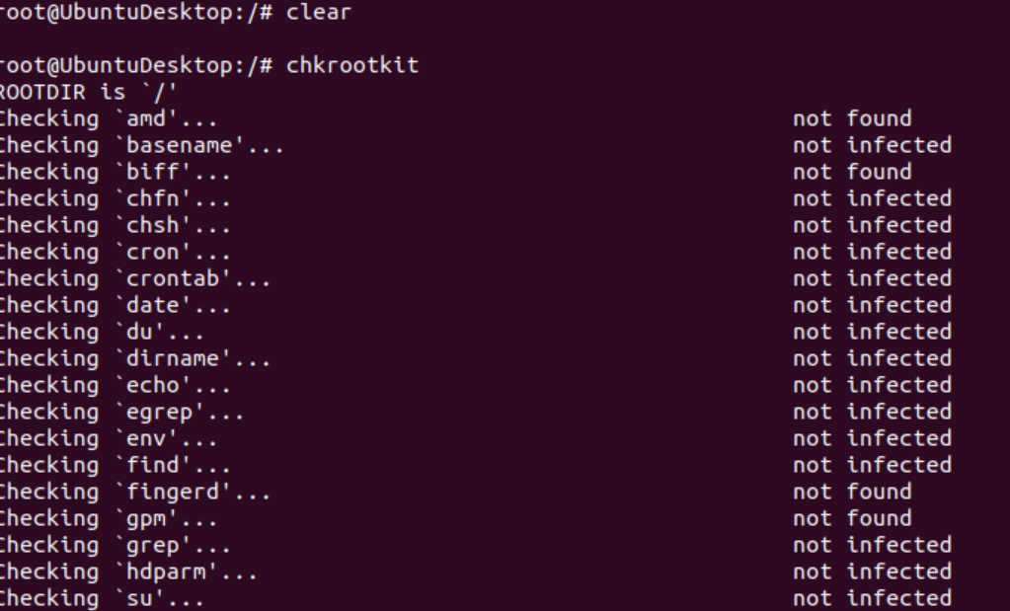

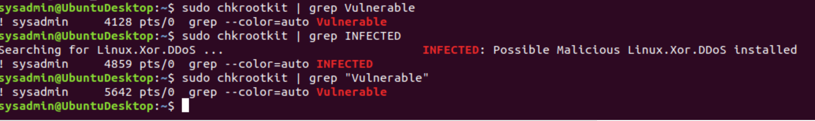

Ways to harden:

* Identify your enterprise’s needs for protection, access, and performance
* Define “mission critical” for your specific environment
* Take advantage of next-generation firewall capabilities for DDoS mitigation
* Ensure that enterprise systems are not running on manufacturers’ default configurations